LBNE – in the mean time

Foreward.

The opinions expressed here represent a suggestion of how to move forward, whether or not the funds needed for LBNE are made available. It is, in some sense, a no lose scenario.

Today’s Landscape

The neutrino landscape is very quickly changing. The jury is still out about whether q13 really is as large as T2K suggest, but assuming they have not completely underestimated their background, it does look like they have seen appearance of electron neutrinos coming from sub-dominant oscillations of nm. The reactor experiments are about to come on line and should have at least confirmed the very large T2K q13 (q13=10o) by early next year (2012).

If q13 really is as large as this then many of the challenges that LBNE is looking to solve can be accessed at the NOVA baseline.

What really are the next Big Questions in neutrino physics? While measuring dcp is academically interesting, it does not lead to leptogenesis. It is an example of how CP violation happens to the left-handed light neutrinos, but it is the DL=2 transition of heavy RH Majorana neutrinos which is needed for leptogenesis and the baryon-antibaryon asymmetry of the Universe. The mass hierarchy is more important: it could lead to the confirmation that neutrinos are Dirac particles before the end of the next decade. If the hierarchy is inverted and double beta decay is not seen in the next generation of experiments whose reach should be down to 50 meV, Majorana neutrinos will be ruled out.

Let us take two scenarios.

A: q13 is moderate: 6o (sin22q13=0.043)

B: q13 is small: 3o (sin22q13=0.01).

Scenario A:

Reactor experiments will take 2-4 years to reach this sensitivity. T2K will come back online, and NOVA will start up. Watching the recent results from T2K shows how fast a well picked baseline experiment can become competitive. By end of 2013 there should be evidence from T2K and possibly NOvA that q13 is > 5o. What is the next thing to do?

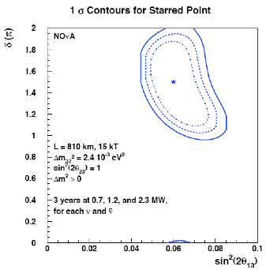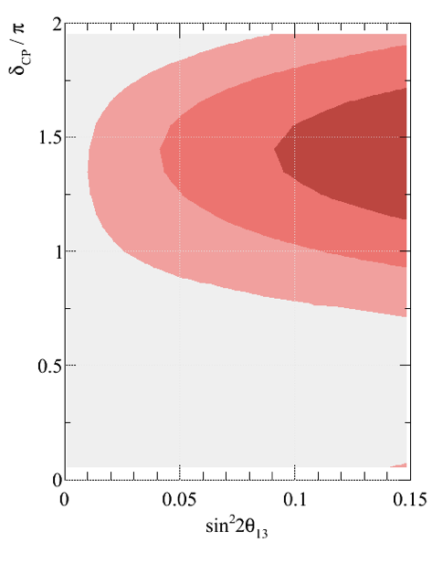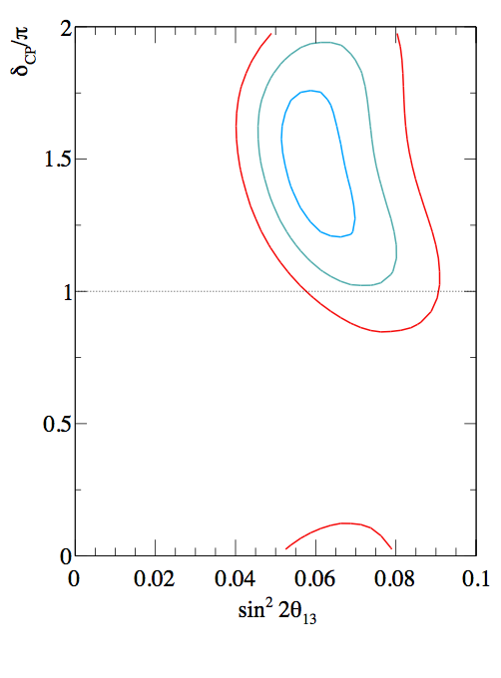

The above figure (far left) shows the status of our knowledge by 2019 combining Nova & T2k wih the reactor experiments. The vertical region is the estimate of how well the reactor experiments would know a q13 at this value (about 10%). The mass hierarchy will not be accessible to NOVA at all unless there were higher beam power or alternatively, more mass. At this q13 there would still be some information to be gained on ruling out some dcp parameter space, but this would not be definitive. Within the next 6 years starting, say, in 2012, it would be possible to augment Nova with 6kT-10kT of LAr. Conservatively, ton for ton, LAr is worth 3x the NOVA mass. This would have several advantages.

Outcome: By augmenting NOVA with 10kT or LAr, we would know the mass hierarchy, and where to focus on dcp within 10 years. This is shown in the figure above (right) which is a simulation for 14kT of Nova with a 2.3MW beam. This is equivalent to 14kT of Nova and 10kT of LAr with a 700kW beam. Colors are white-red, 1-2,2-3,3-4,4-5 sigma. The plot 2nd from right shows the level of accuracy that dCP could be measured with if q13 is in the region of 0.04-0.05 (only estimates available)

We need to compare this to where we would be with LBNE in this scenario. It is possible (optimistically) that in 10 years time the cavern is ready and the detector has been built. The new beamline might be ready, and maybe even a year of running is already collected. Nevertheless, it will not have contributed additional information at this juncture.

Scenario B:

Reactor experiments will take 4 or 5 years to reach the sensitivity of 0.01 (or longer) while Nova and T2K will continue to run for a further 2 years (7 years from now) to push down on q13.

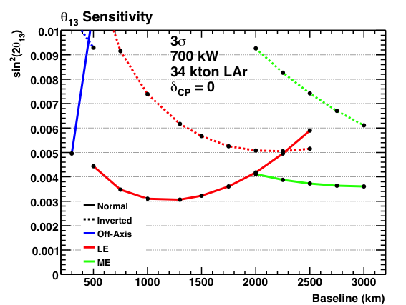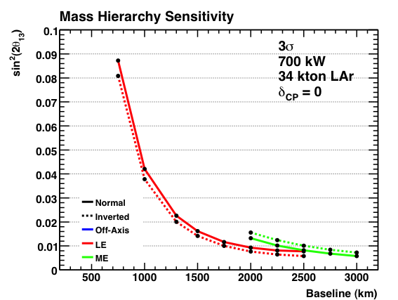

During that 7 years, money could be spent on the development of a higher intensity beam, either at Project-X or at NuMI. Nova + 10kT of LAr with a 1.2MW beam would provide further reach. The figure above center shows the reach of LBNE: but this is just a function of the mass of the detector and the divergence of the beam and is probing the first oscillation peak like Nova, using a LE beam. This is equivalent to augmenting the Nova site with more mass, indeed augmenting NOVA with the full 34kT LAr detector would give NOVA a much extended reach in q13 . The figure above left shows that a large region of dCP is still undetermined, even with the equivalent of 10kT of LAr in addition to NOVA (equivalent of 2.3MW running). This combination is not systematics limited and more mass and more running will just improve this reach.

Outcome: we would know q13 within 10 years. The plot above right shows the question we would be asking at that point. Where should we put the detector to get at the mass hierarchy? The plot shows that the LE beam gives the best mass hierarchy discrimination, and the result assumes 5+5 years of running. For a 3s measurement, we might just make it at 2000km but the longer the baseline the further the gain and at this point, more mass or more intensity cannot alone achieve the sensitivity. It is only a longer baseline that can help.

Observations.

Making a decision today on where to put the LBNE is premature and worse, could leave LBNE in the position of doing no better than NOVA could, after a much longer time frame. We could wait to see what q13 is before choosing the baseline. With semi-transportable LAr detectors (there are ships with cryostats that sail around, so this isn’t an impossible goal) the baseline could be chosen after the fact rather than before. LAr technology is the new frontier for neutrino experiments, FNAL has the infrastructure and expertise, and is in a good position to develop the concept of transportable devices to be able to react to short and long baselines alike. There are several different off axis angles which could provide specific information on CP violation, if sites can be found. These studies were done by Rameika et al and can be found in the LBNE DocDB.

Conclusion

I would argue that an adiabatic improvement to the NumI facility and an enlargement of Nova reach using LAr technology will put FNAL in a leading position for the next two decades. It would allow FNAL to take the lead in LAr technology, take the lead in measurement of the mass hierarchy (if q13 is large) , take the lead in q13measurement (if q13 is small), and to focus on Project –X for delivery of a super high power neutrino beam at some point in the future together with hopefully an array of LAr detectors ready to measure wherever it is pointing.